**CHAPTER FOUR**

# IMPLEMENTATION

**4.0 SYSTEM IMPLEMENTATION**

After the completion of system’s design phase of any system is the phase of implementation. All designs are set into work here at this stage that is this is the stage where all theory in turned into absolute practice. The designed system can be loaded to the computer at this stage and a proper usage of the system is carried out. Implementation is key to every system as any system no implemented is an incomplete or incompetent system.

## 4.1 Implementation Environment

PHP is used as a programming language for the implementation of the design. The programming environment for the database is Mysql which is connected to PHP.

## 4.2 Choice of Programming Language

**The reasons for the choices of language are:**

1. Familiarity with PHP and its environment
2. Flexibility and adaptability of MySql with PHP
3. Availability of the support and link tools (MySql) driver
4. Availability of large collection of libraries
5. PHP being an object Oriented Language

## 4.3 Hardware Requirement

1. Minimum of Pentium 111 233 MHZ or higher Processor
2. RAM Memory Requirement: minimum 256MB
3. 1.2 GB Hard disk space or higher
4. SVGA Monitor
5. Enhance or standard keyboard
6. Mouse

## 4.4 Software Requirement

1. Operating System: Linux OS, Windows XP, Vista.
2. XAMPP WEB SERVER
3. MYSQL Database.

## 4.5 Data Gathering Methods

The existing manual system was examined; important information and data necessary for the proposed new system were extracted and recorded**.** Questions were asked where necessary and adequate answers were provided. The challenges of the old system were identified and noted. The procedure of carrying out daily activities also noted.

## 4.6 SYSTEM DESCRIPTION

**The Examination system consists of the following parts**

**HOMEPAGE:** provides various links for both users and administrator to different pages.

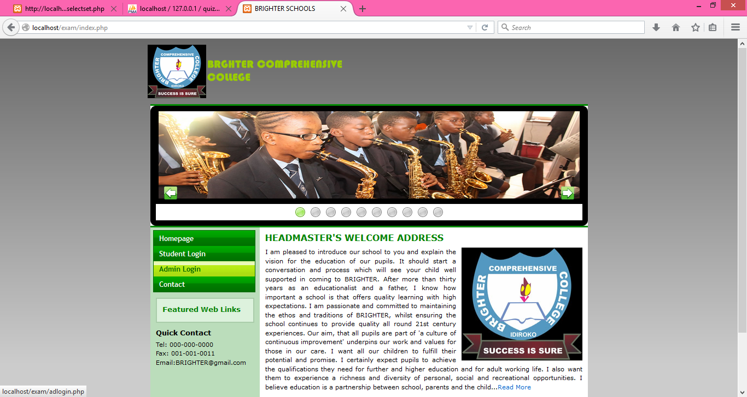

**ADMINISTRATOR PAGE:** provides various links for different operations for the administrator.

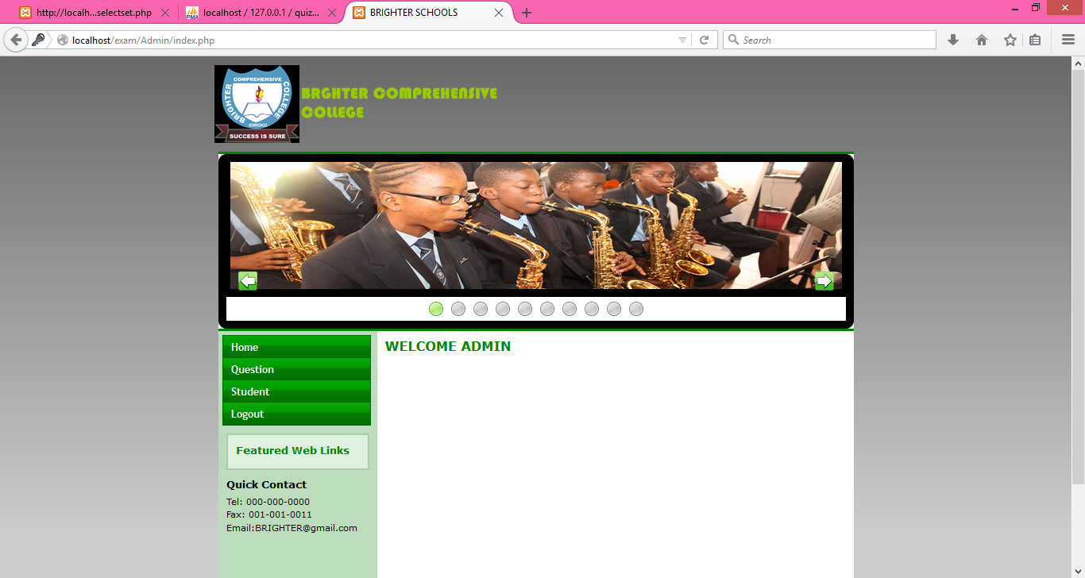

**STUDENT HOMEPAGE:** provides various links for different operations for the users

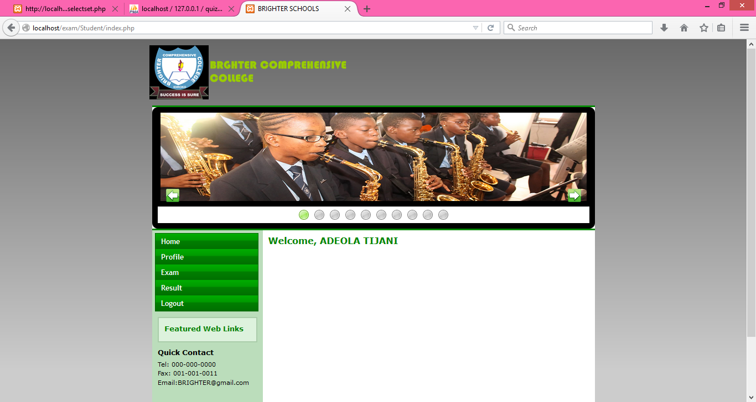

**EDIT STUDENT DETAILS PAGE:** enables each student to edit their profile

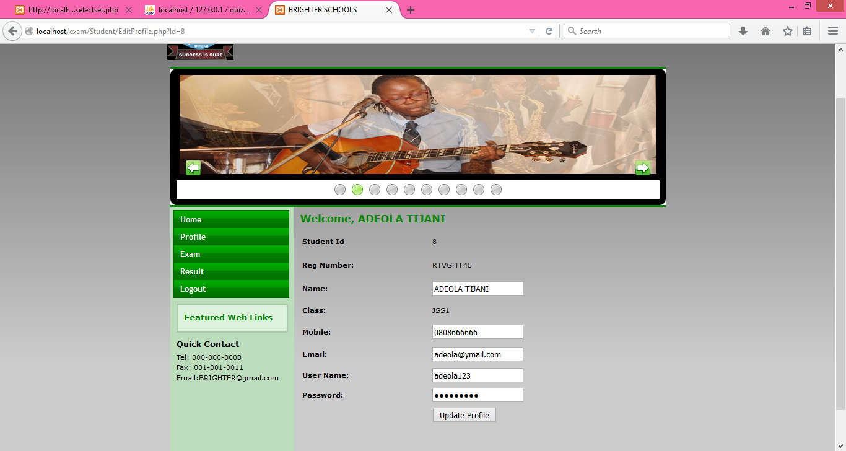

**VIEW STUDENT DETAILS PAGE:** shows the details of each student**.**

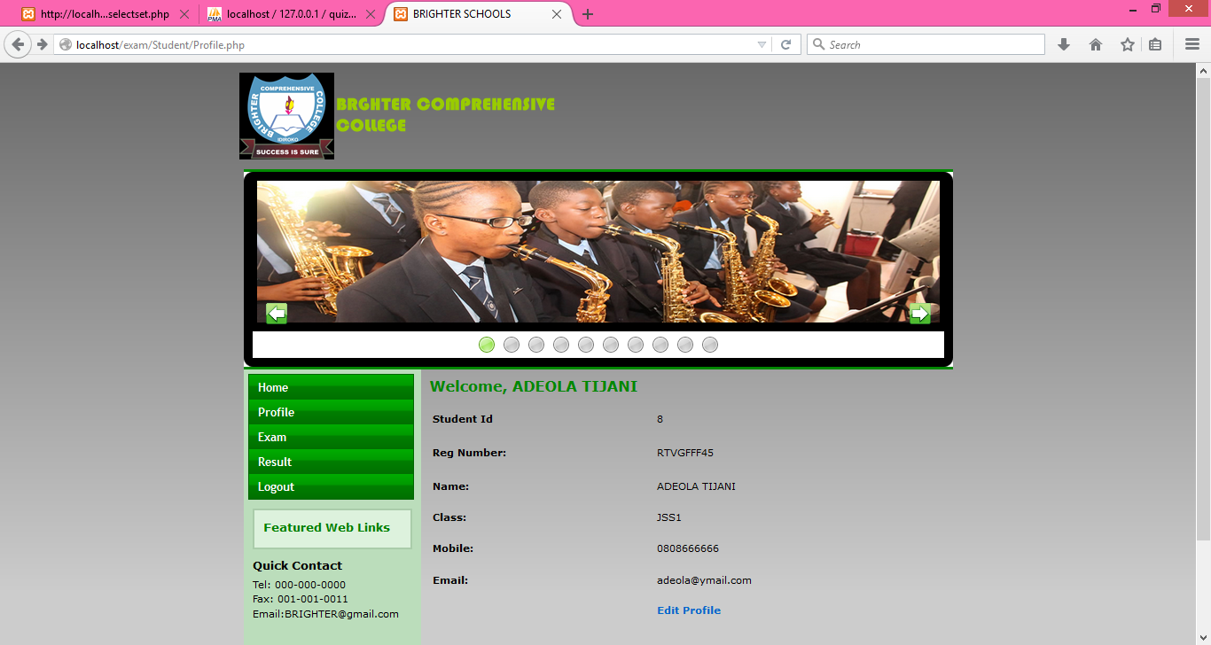

**EXAM REPORT:** shows the report of student scores according to course code

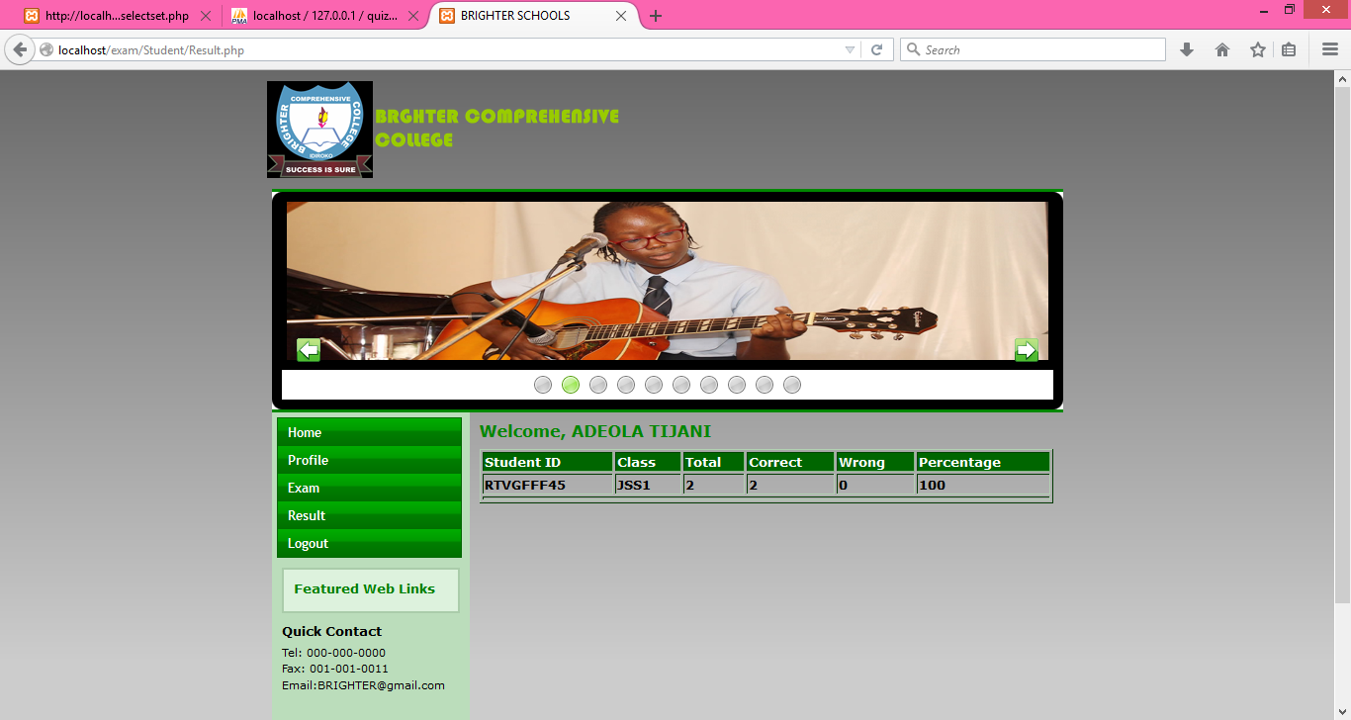

**SET QUESTION PAGE:** enables the administrator to add set questions

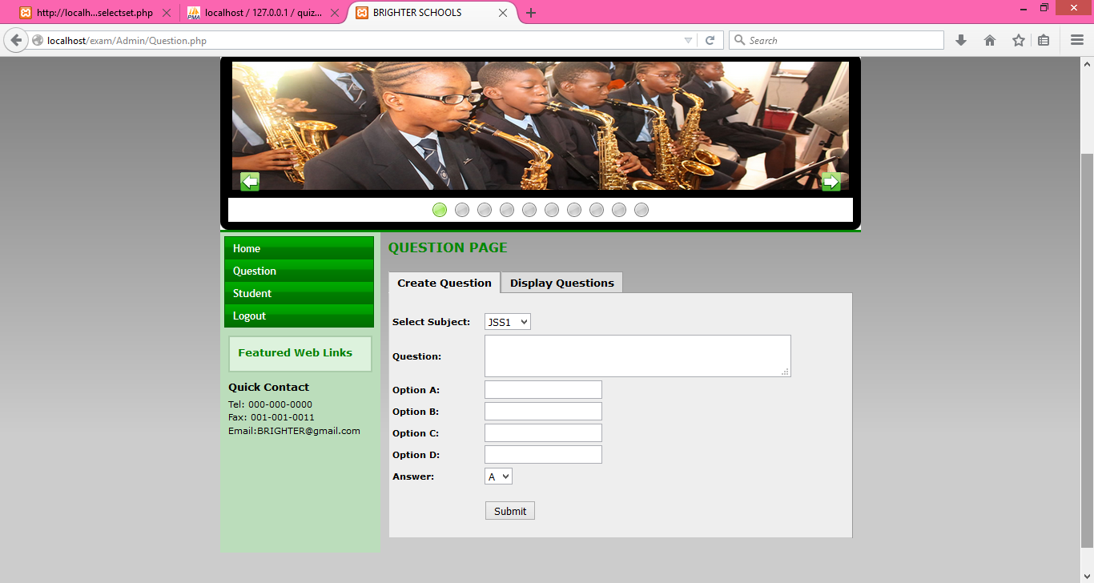

**4.4 SYSTEM TESTING**

System testing is described as the test conducted on a total integrated system to weigh up the system’s conformity with it precise desires. The proposed system has been tested with real life data and information. Each program modules in this project has been carefully and thoroughly tested with appropriate data to ensure it works as expected.